**INDUSTRIAL UNIVERSITY OF HO CHI MINH CITY**

**FACULTY OF INFORMATION TECHNOLOGY**



GRADUATION THESIS

**REPORT - WEEK 02 –**

**DICOM STANDARD**

SUPERVISOR: HIEU TRUNG HUYNH, Ph.D.

HO CHI MINH CITY – 01/2018

# table of contents

Page

Table of contents

1. Introduction 3

2. DICOM file format 3

2.1 Model of the real world 4

2.2 DICOM file structure 6

3. DICOMweb 7

3.1 Overview 7

3.2 WADO-RS Request/Response 8

3.2.1 RetrieveStudy 8

3.2.2 RetrieveSeries 8

3.2.3 RetrieveInstance 8

3.2.4 RetrieveFrames 8

3.2.5 RetrieveBulkdata 8

3.2.6 RetrieveMetadata 8

# Introduction

DICOM - Digital Imaging and Communications in Medicine - is the international standard for storing and transmitting medical images enabling the integration of medical imaging devices such as scanners, servers, workstations, printers, network hardware, and picture archiving and communication systems (PACS) from multiple manufacturers. It has been widely adopted by hospitals, and is making inroads into smaller applications like dentists' and doctors' offices.

DICOM files can be exchanged between two entities that are capable of receiving image and patient data in DICOM format. The different devices come with DICOM Conformance Statements which clearly state which DICOM classes they support, and the standard includes a file format definition and a network communications protocol that uses TCP/IP to communicate between systems.

DICOM is recognized by the International Organization for Standardization as the ISO 12052 standard.

# DICOM file format

It is inherently similar to well-known formats such as JPEG, PNG or TIFF. However, besides the so-called “pixel data” that encodes the medical image itself, a DICOM file also embeds medical information.

## Model of the real world

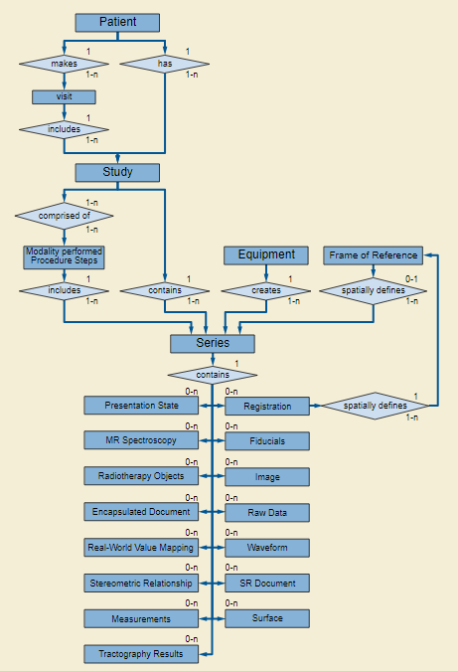

Figure 2.1. DICOM file model of the real world

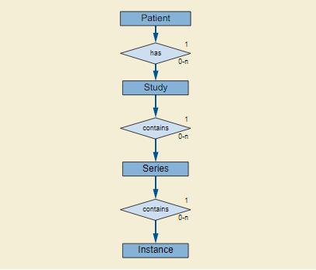

Figure 2.2. Retrive information model

The diagram shows that a given patient benefits during her life from a set of medical imaging studies. Each study is made of a set of series. Each series is in turn a set of instances, the latter being a synonym for a single DICOM file.

The patient level is the top level and contains Attributes associated with the Patient Information Entity (IE) (e.g., Patient’s Name, Patient ID, Patient’s Sex…). The study level is below the patient level and contains Attributes associated with the Study IE (e.g., Study Date, Study Time, Accession Number,…). The series level is below the study level and contains Attributes associated with the Series (e.g., Modality, Series Number, Series Instance UID,…). The lowest level is the Composite Object Instance level and contains Attributes associated with the Composite object IE (e.g., Instance Number,…).

## DICOM file structure

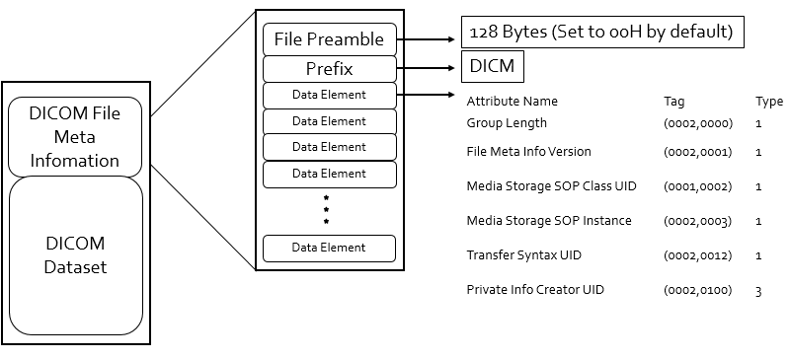

Figure 2.3. DICOM file structure

The medical information encoded by a DICOM file is called a dataset and takes the form of a key-value associative array. Each value can itself be a list of data sets (called a sequence), leading to a hierarchical data structure that is much like a XML or JSON file.

In the DICOM terminology, each key is called a DICOM tag. The list of the standard DICOM tags are normalized by an official dictionary, each tag being identified by two 16-bit hexadecimal numbers. For instance, the birth date of a patient is associated with the DICOM tag (0x0010, 0x0030). Note that it is common to drop the “0x” prefix and to simply write 0010,0030. For better readability, it is also common to nickname these DICOM tags with a camel case English name (such as “PatientName” or “StudyDescription”). The standard associates each DICOM tag with a data type (a string, a date, a floating-point number...), that is known as its value representation.

# DICOMweb

## Overview

DICOMweb is a term applied to the family of RESTful DICOM services defined for sending, retrieving and querying for medical images and related information. DICOM Web Services use the HTTP and HTTPS protocols as its transport medium.

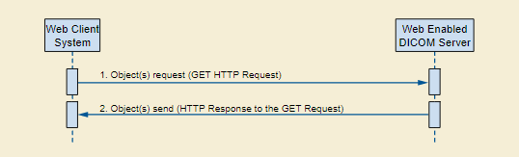

Figure 3.1. Interaction diagram

The client of a DICOM service is called a service class user (SCU), and the server that handles the requests is called a service class provider (SCP). The client sends a request that is encoded as a DICOM file (the command), and the server answers with a DICOM file.

DICOMweb services:

|  |  |
| --- | --- |
| **Service** | **Description** |
| Query | Search for DICOM objects (QIDO-RS - Query based on ID for DICOM Objects) |
| Retrieve | Retrieve DICOM objects (WADO-RS - Web Access of DICOM Objects) |
| Store | Store DICOM objects (STOW-RS – Store over the web) |
| Worklist | Manage worklist items (UPS-RS) |
| Capabilities | Discover services |

The next section, we just focus on studying about WADO protocol.

## WADO-RS Request/Response

The DICOM RESTful Service defines several action types. An implementation shall support all the following six action types:

### RetrieveStudy

This action retrieves the set of DICOM instances associated with a given study unique identifier (UID). The response can be DICOM or bulk data depending on the "Accept" type, and is encapsulated in a multipart MIME response.

### RetrieveSeries

This action retrieves the set of DICOM instances associated with a given study and series UID. The response can be DICOM or bulk data depending on the "Accept" type, and is encapsulated in a multipart MIME response.

### RetrieveInstance

This action retrieves the DICOM instance associated with the given study, series, and SOP Instance UID. The response can be DICOM or bulk data depending on the "Accept" type, and is encapsulated in a multipart MIME response.

### RetrieveFrames

This action retrieves the DICOM frames for a given study, series, SOP Instance UID, and frame numbers. The response is pixel data, and encapsulated in a multipart MIME response.

### RetrieveBulkdata

This action retrieves the bulk data for a given BulkDataURI.

### RetrieveMetadata

This action retrieves the DICOM instances presented as the study, series, or instance metadata with the bulk data removed